JUNIOR OLYMPIC

NOTICE OF RACE GUIDELINES

Comments in bold italics are instructions, explanations or questions to be used in finalizing the Notice of Race (NOR). This generic NOR should be used as a guide with the final product being kept simple and informative. Changes may be made to reflect the needs and desires of the Organizing Authority.
Refer to the Racing Rules of Sailing 2017 - 2020, Appendix J, Notice of Race and Sailing Instructions and Appendix K, Notice of Race Guide for additional information.

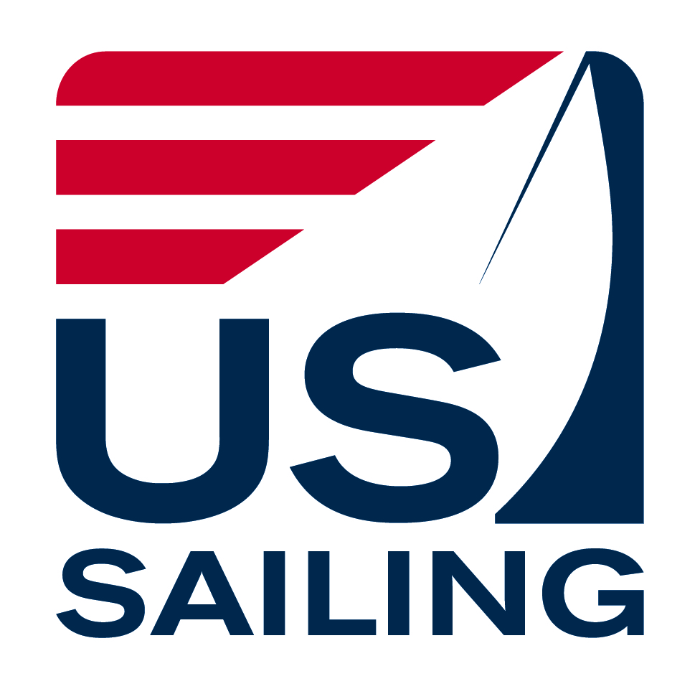
USA JUNIOR OLYMPIC SAILING FESTIVAL
[event name or region]

[Date]

[XYZ Yacht Club, City, State]
National JO Sponsors:
New England Ropes
- [list local sponsors here]

[club
burgee
here]

Organizing Authority: XYZ Yacht Club

N O T I C E O F R A C E

- RULES
  - The regatta will be governed by the rules as defined in The Racing Rules of Sailing (RRS).
  - . For the purposes of the definition of rule, the class rules shall be the rules of the [insert class names here – e.g., Laser, Club 420, Laser Radial, Optimist, etc.] class.

  - The following rules will be changed: rule 40 and A2. These changes will also appear in full in the Sailing Instructions. Additional rules may also be changed in the Sailing Instructions.

- ELIGIBILITY & ENTRY
  - AGE
Applicants for all classes must not turn ## years old* in the year of the event. Optimist class age rules apply.
[*Age limits for JO events are determined by local organizers, not US Sailing.]

  - US SAILING MEMBERSHIP
Membership in US Sailing is required for each competitor (helmsman and crew for doublehanded classes). Sailors can join online at www.ussailing.org/membership.

  - CLASS ASSOCIATION MEMBERSHIP
US Sailing recommends that competitors are members of their respective class associations (i.e., Optimist, Laser, Club 420, etc.).

  - GREEN REGATTA
This regatta is a Sailors for the Sea "Clean Regatta." All competitors are encouraged to use non-single use water bottles and recycle all appropriate items. Competitors are reminded of rule 55 which states that competitors "shall not intentionally put trash in the water."

- BOATS/MEASUREMENT
  - Boat class [fill in class] with crew of [fill in number of crew] including helmsman, will be used. [Repeat for each class. - Classes are determined by local event organizers. You are encouraged to include any class that can produce a fleet (five or more boats), whenever possible.]

  - Competitors are encouraged to bring their own boats. A limited number of [insert classes] are available [for charter/to borrow].

  - All boats must have a floating bowline of appropriate length.

  - Each competitor will be responsible for their boats being in compliance with the class rules.
- FEES
The entry fee for all classes is $ [insert amount] per boat or competitor. The entry fee includes [fill in what is included in entry fee, e.g., an official USA Junior Olympic T-shirt, lunches, dinner, clinic, trophies, etc.]. The first [insert number] registrants will also receive a goodie bag filled with lots of great stuff.

- SCHEDULE OF EVENTS
DAY, DATE Registration & check-in, competitor briefing, clinic
DAY, DATE(S) First race of the series, of ## races scheduled
DAY, DATE Awards presentation

The Green Fleet schedule will be the same through the Skippers Meeting at which point a second, separate meeting for Green Fleet sailors may be conducted and the remainder of the schedule for that fleet will be announced.

- ADVANCE REGISTRATION - Competitors shall register in advance by registering online at __________. Entry deadline is; [date]. Late fee of $ [insert amount] applies thereafter.

- SAILING INSTRUCTIONS - The Sailing Instructions (SIs) will be available at registration and on the web at: [insert web address].

- SCORING - A maximum of [insert number] races are scheduled, of which [insert number] shall be completed to constitute a series. If [insert number] or more races are sailed, a boat’s worst score shall be discarded. This changes rule A2.

- COACHES - Coaches may be asked to register. Coaches who bring proof of US Sailing certification will be given appropriate access to participants and recognition. All coach / parent boats shall register with the Race Committee. Each coach / parent boat shall have a working VHF radio. The conduct of registered support boats and all other boats including spectator boats shall be governed by The Racing Rules of Sailing and the Sailing Instructions. [Add more as needed to encourage the conduct desired by the coaches.]

- SAFETY - A US Coast Guard approved personal flotation device shall be worn, properly fastened, at all times while launching and when sailing, except briefly when adding or removing clothing. Each competitor is urged to have a whistle attached to their PFD. Failure to comply with this rule may result in disqualification. A boat retiring from a race shall notify a Race Committee vessel before leaving the course, or when that is impossible, [Insert shore location] immediately after arrival ashore.

Optional safety language: An adult (parent, guardian or designated adult) is responsible for the safety of each sailor. It is the responsibility solely of this adult to decide if the sailor should sail in the weather and sea conditions that might arise during the event. The adults supervising the competitors are ultimately responsible for the risks.

Parents not personally attending the event must ensure that another adult is authorized and designated to make these decisions for their sailor and each competitor shall indicate in writing the parent or adult representative that shall be responsible for the competitor throughout the event.

The designated adult will accept full responsibility for all actions of the competitor during any activity related to the event. This includes on-shore activities before, during, and after the Regatta.

- MEDIA RIGHTS - By participating in this regatta, a competitor (or parent/guardian if under age 18) grants to the OA, US Sailing and their sponsors the right in perpetuity to make, use and show, from time to time at their discretion, any photographs, motion pictures and live, taped or filmed television and other reproductions of him or her during the period of the competition without compensation.

- DISCIPLINE
  - Per US Sailing Regulation 10.03 no participant or competitor shall use or possess, either on or off the water: 1) marijuana or any other substance if possession is illegal under state or federal law; or 2) any alcoholic beverages. This regulation is in effect from date and time of arrival through date and time of departure from the venue.

  - All competitors are expected to maintain the highest level of conduct throughout the entire event. When the Protest Committee, from its own observation or a report received from any source, believes that a competitor may have committed a breach of good manners, a breach of good sportsmanship, unethical behavior or conduct that may bring the sport into disrepute, it may call a hearing. After a proper hearing the penalty may range from a reprimand to dismissal from the regatta and additional action may be taken under RRS 69.

  - Hearings will be held generally in accordance with the recommendations of Appendix M5 of the RRS. The officers for hearing a violation will consist of the Chief Judge, acting as chairman of the hearing, the Protest Committee and the event chair.

- PRIZES
Junior Olympic medals will be awarded to competitors placing first through third in all divisions. Green Fleet medals will be awarded to all Green Fleet participants.
[List other awards here – greatest distance traveled, youngest, sportsmanship, as well as fourth and higher in larger fleets.]

- FURTHER INFORMATION
Contact [insert name, address, phone, email address here] and check the website for further information.

- Venue: Camping allowed? Pets allowed?

Host Club:
- Club Name
Physical Address
City, State, Zip
Phone
Web address

Regatta Chair:
Event Chair Name
Phone
Email address

Disclaimer of Liability
Sailing is an activity that has an inherent risk of damage and injury. Competitors in this event are participating entirely at their own risk. See RRS 4, Decision to Race. The race organizers (organizing authority, race committee, protest committee, host club, sponsors, or any other organization or official) will not be responsible for damage to any boat or other property or the injury to any competitor, including death, sustained as a result of participation in this event. By participating in this event, each competitor agrees to release the race organizers from any and all liability associated with such competitor's participation in this event to the fullest extent permitted by law.

---------------------------------------------------------------------------------------------------------
ADDITIONAL RECOMMENDATIONS

LIFE JACKETS
Each competitor is urged to have a whistle attached to his or her life jacket.

All support people on the water – race committee, mark and safety boat operators, parents, etc. – are strongly encouraged to wear PFDs.

The social schedule, housing and transportation information are not part of an official Notice of Race but can be very important to competitors, coaches and parents. Include a schedule of all non-racing and social activities.

