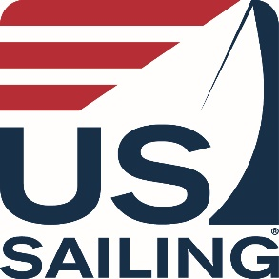

MEDICAL AND EMERGENCY INFORMATION
Voluntary Medical Disclosure & Emergency Contact Form
(Please complete this form before your instructor course)

Note: This form is to be completed only by Instructor Candidates (or the parent/guardian of Instructor Candidates who are minors) who wish to disclose medical conditions that Instructor Trainers, staff, or medical personnel should be aware of during this course. This form and the information contained herein will be kept secure and confidential during this course and will thereafter be returned to the Instructor Candidate.

Instructor Candidate Name: ______________________________________________________

Emergency Contact(s)
Name | Relationship | Phone Number

Please provide any medical condition or allergies that the Instructor Trainers, staff, or medical personnel should be aware of while you are enrolled in this course:

Please provide any relevant instructions or directions that may be useful for Instructor Trainers, staff, or medical personnel:

_________________________________________________________
Instructor Candidate Signature (or parent/guardian if minor)

____________________
Date

