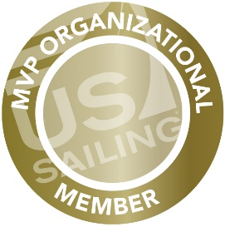
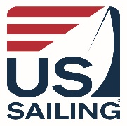

Dear <<>>,

Sailing means something different to each of us. Whether we are long time sailors, racers, volunteers, or new to the sport, we all choose to belong to {{org name}} because we know there is nothing quite like being on the water and part of a community.

{{org name}} is a member organization of US Sailing, and a part of their MVP Program. Being an MVP partner enables {{org name}} to receive credits when you join or renew your annual US Sailing membership at a discounted rate through the program. Your membership will directly give back to our programs, as {{org name}} earns credits for each membership purchased. {{org name}} can use these credits to pay for nearly everything at US Sailing. This includes:

- Purchase sailing program and educational materials, supplies, gear, and more from the US Sailing Store.
- Fund US Sailing courses and regattas we run or create the potential to run such events.
- Keep our instructors and race officials up to date on the latest trainings and certifications to better serve our community.
- Count towards our US Sailing Membership dues.
- Ability to send representatives from our organization to attend US Sailing’s National Sailing Programs Symposiums and bring back learnings and materials to better our organization and the programs we offer to our members
{{Paste custom registration link from email here}}

Thank all of you who are current US Sailing members and for those who are not yet members, please consider following {{org name}}’s lead and become a member of US Sailing today. In addition to receiving a discounted membership through the MVP Program, US Sailing membership provides you with dozens of member benefits including:

- Access to the new Racing Rules of Sailing app
- Discounts up to 75% from US Sailing partners like Gill, Sailing World & Cruising World Magazines, charters with The Moorings, Boat US, Zim Sailing, and many more!
- Access to exclusive marine insurance offerings from Gowrie Group
- Youth access to US Sailing’s Skill Up training app

We hope you will join us in our partnership with US Sailing and thank you for your commitment to both our sport and our {{org name}} community.

<<Organizational Leader Name>>

