US Sailing
Regional Administrative Judge Guide
(RAJ-GU)
February 2023
US Sailing is the National Governing Body for sailing. Our mission is to provide leadership, integrity and advancement for the sport. Founded in 1897 and headquartered in Bristol, RI, US Sailing is a 501(c)3 non-profit organization.

© 2023 by the United States Sailing Association.

All rights reserved. No part of this publication may be reproduced, stored in a retrieval system or transmitted, in any form or by any means, electronic, mechanical, photocopying, recording, or otherwise without prior written permission from US Sailing.

Second Edition
Printed in the United States of America

US Sailing
1 Roger Williams University Way Bristol, RI 02809
www.ussailing.org
Acknowledgements

February 2020

The Regional Administrative Judge Guide (RAJ-GU) is distributed to the members of the Judges Committee (JC) and placed in the secured area of the Judges Committee document folder online at the US Sailing website. The RAJ Guide is not for general publication, but may contain forms, sections or parts that may be published and distributed to certified judges.

All members of the JC are responsible for ensuring the rules of use and implementation of the Judges Manual and RAJ Guide are followed.

This version of the RAJ-GU created by Nancy Zangerle, Wayne Balsiger, Nancy Glover, Edith Collins and Craig Daniels, edited in 2022 by John Porter, Craig Daniels, Mary Pierce

Editors’ Note

This edition is not perfect. We did not let perfection get in the way of good. We fully expect additions and improvements to be made in the future. This “good to know” information is now yours to use.

John Porter, Editor Second Edition
Wayne Balsiger, JC Chair

Table of Contents

Index of Terms and Abbreviations 1
1 Regional Administrative Judge 2
Selection 2
Appointment 2
Term of Office 2
2 Roles and Responsibilities 3
Coordinate Judge Training in Their Area 3
Recruiting Seminar Hosts and Scheduling 3
Obtaining Instructors 3
Publicity 3
Testing 4
Promote Continuing Education for Judges 4
Judge-in-Training 4
3 Certifying Judges 5
Overview 5
Levels of Judge Certification 5
Recruiting and Certifying Club Judges 5
Approval 6
Certifying & Renewing Regional and National Judges 6
Processing Applications 6
Certification & Renewal for RAJs 7
Annual Activity Reporting for RJs and NJs in Area 7
Follow Up on Renewals of Certification in Area 7
Complaints about Race Officials 8
Attend US Sailing Judges Committee Meetings 8
Prepare for JC Meetings 8
Provide Leadership in Judging in the Area 9
Judging Support for Area US Sailing Regattas 9
SafeSport 9
Background Checks 10
Policy on Use of US Sailing Logo by Certified Officials 10
Extensions to Recertify 10
Developing a Plan for Improvement 10
Judge Emeritus 11
International Judge Appointment Requirements 11
4 Judges Committee 14
Purpose 14
Functions and Activities 14
Composition 15
5 Judges Committee Leadership 16
Judges Committee Chair 16
Judges Committee Vice-Chair 16
Judges Committee Secretary 16
Judges Committee Working Parties & Subcommittees 17
Standing Subcommittees 17
Judges Education Training and Testing Subcommittee 17
Web Liaison Subcommittee 17
6 References 18
Links 18

Index of Terms and Abbreviations

AJS Advanced Judge Seminar
AGM US Sailing Annual General Meeting
Area The geographical jurisdiction of US Sailing Regional Sailing Associations delineated by the Board. An Area may contain more than one RSA.
CEE Continuing Education Event
CEU Continuing Education Unit
CJ US Sailing Certified Club Judge
CJ The appointed Chief Judge at a regatta or event
CJPD Club Judge Program Director
CJS Club Judge Seminar
IJ World Sailing Certified International Judge
JC US Sailing Judges Committee
JCAM Judges Committee Administrative Manual
JE Judge Emeritus
JETTS Judges Education Training and Testing Subcommittee
JIT Judge-in-Training
JM US Sailing Judges Manual
LSO Local Sailing Organization
MNA A Member National Authority recognized by World Sailing
NGB A National Governing Body for an Olympic/Paralympic sport
NJ US Sailing Certified National Judge
OA Organizing Authority
RAC Race Administration Committee
RAD Race Administrative Director
RAJ Regional Administrative Judge
RAJ-GU Regional Administrative Judges Guide
RJ US Sailing Certified Regional Judge
RO Race Officer
RSA Regional Sailing Association
SOARS Sailing Official Automated Reporting System
WP Working Party
WS World Sailing

Regional Administrative Judge

The Regional Administrative Judge is a leader in the field of Judging in their area. They are a resource for “how things work.” They help facilitate learning, growth opportunities, and education for Judges. In addition, they often help Judges and others find and utilize US Sailing Resources. Often, they will answer inquiries about rules, procedures, or other judging related topics.

Selection
The outgoing RAJ should identify possible replacements and discuss them with the Chair of the Judging Committee, who, after consulting with the Area Coordinator, makes the appointment. The nominated RAJ should be a Regional Judge (RJ) or National Judge (NJ). The appointment shall be presented to the US Sailing Board of Directors to be approved at a board meeting.

Appointment
RAJs are appointed in accordance with US Sailing Regulation 6.02.

Term of Office
The RAJ shall serve on the Judges Committee for a term of three (3) years beginning on January 1st and after approved by the US Sailing board of directors. RAJs may not serve more than two (2) consecutive terms unless the Judges Committee and the US Sailing Board of Directors approves an exception. A new RAJ may also complete the unexpired term of the previous RAJ in addition to his or her own terms.

Roles and Responsibilities

Coordinate Judge Training in Their Area
Each RAJ should work with the Local Sailing Organizations (LSOs) in their Area, and with the US Sailing Education Department, to advise and assist with scheduling and organizing US Sailing Judge training seminars.

Recruiting Seminar Hosts and Scheduling
RAJs work with LSOs to understand the need and demand for various levels and types of training events; ensure they understand the process and requirements for scheduling Judge Seminars in their area. The RAJ provides critical input to avoid duplication of effort and scheduling conflicts.

Club Judge Seminars and Advanced Judge Seminars must be approved by the RAJ.

Advanced Judge Seminars must be approved by the Chair of the Judges Education Training and Testing Subcommittee (JETTS). The appropriate frequency of both Basic and Advanced seminars in each Area depends on the number of candidates, history of recent seminars and the geographic area to be covered. RAJs should discuss any questions with the RAD and/or Education department.

RAJs should reply to the proposed organizer and the US Sailing scheduling coordinator within 14 days of receipt of a request to confirm the location and time or to suggest a more suitable venue or date. If the Education department doesn’t hear from the RAJ and/or JETTS chair, they will assume approval is given and schedule the seminar.

Obtaining Instructors
RAJs assist the seminar organizers and work with the seminar host and scheduling coordinator at US Sailing to suggest certified instructors to JETTS for each level of seminar (see the Find an Instructor page). To the extent possible, the RAJ and RJs or NJs from the Area should be used as assistant instructors and helpers at these seminars.

Publicity
The RAJ works with LSOs, the scheduling coordinator and appropriate outlets to publicize and promote attendance at the seminars.

Mailing lists of Sailing Organizations in your area: There are several US Sailing resources that can be used for publicizing events and seminars. One is the Where to Sail database on USSailing.org. This is manual extraction of information.

Testing
The RAJ may be called on to arrange a test debrief if a candidate fails a test (Please see both Testing Guidelines, and Test Introduction under Online Testing Information). The instructor and/or the RAJ may conduct debrief in person or by web conference (which US Sailing can arrange). Please coordinate with the instructor if you receive a debrief request. The test taker now receives the answers to incorrect questions so this has reduced the need for debriefs.

Test scores can be viewed in the candidates SOARS log once test results have been uploaded. The RAJ and instructor may wish to consult on a plan of improvement for the candidate before he or she takes the test again. See web conference – Hosting your own under References, Web Conferences.

Promote Continuing Education for Judges
The JC is working towards more CEU events for recertifying judges, so they are not required to attend a Judge seminar to qualify for renewal. These include Protest Day, Judges Roundtables, specific training modules, and SafeSport renewals. See Continuing Education below for more information and number of CEU for each activity.
How to host and certify an event is on the Organize a Seminar page.

Here is a link to the Continuing Education Guidelines.
Continuing Education Events and CEUs Table is a table defining the Continuing Education Units (values) for educational events. These links are also at the end of this guide.

Judge-in-Training
US Sailing offers a Judge-in-Training (JIT) designation to candidates who have attended a seminar, passed the test, and have passed SafeSport training, but need more PC experience, hearing, and/or references to meet certification requirements.

After filling out a JIT application and meeting requirements for JIT designation, candidates may be identified as a JIT and listed in the Find a Race Official list on the website. JITs may be recruited by OAs looking for judges to sit on their protest committees.

When you have potential judges that want to be listed as JITs in SOARS, ask them to fill out the apply to be a race official form, then submit them using the certify a judge form in the JC secure area. This will allow the Judge in Training to show up in a Find a Judge search.

Certifying Judges

Overview
The RAJ is responsible for initial, renewal and upgrades to a candidate’s certification level. Each of these requires an online application to be entered which can be found on the judges’ page at the US Sailing Website. The qualifications for each of these levels are found in the Judges Manual (JM) which is also found on the judges’ website.

Initial certification and upgrades to Regional or National Judge must be vetted by the JC with all supporting documents provided by the RAJ to the committee prior to the JC meeting. The RAJ will present the candidate and lead the discussion. A vote is then taken by the JC (there must be a quorum for the JC) and results provided to the RAD (Race Administration Director) with the RAJ providing communication to the candidate.
Note: this part of the JC meeting is only open to members of the JC.

Renewals are reviewed annually with all candidates for each US Sailing area for a given year summarized on the Judges Renewal form. Each RAJs summary is reviewed by the Chair of the JC and the RAJ prior to the Dec meeting and a copy is sent to all members of the JC. Any judge applicant who does not meet the required qualifications in Chapter 12 of the JM is to be reviewed by all members of the JC. Copies of these forms are sent to the RAD in order to update SOARS and for record keeping.

Levels of Judge Certification
- Judge-in-Training – see prior section
- Club Judge (CJ)
- Regional Judge (RJ)
- National Judge (NJ)
- International Judge (IJ)

For certification requirements see US Sailing Judge Certification Requirements.

Recruiting and Certifying Club Judges
Club judges are the grass roots foundation of an Area’s corps of judges. It is a goal of US Sailing to have a certified Club Judge at each US Sailing member club and LSO.

It can be hard to track all prospective or interested parties. The Race Admin office can email copies of the registration list and contact info for all attendees at seminars and CEEs in the Area to the RAJ.

The RAJ works with Local Sailing Organizations (LSOs) to seek out potential judges and encourage them to attend a seminar, help them gain sufficient experience, guide them through the certification program, criteria, process, etc. Be sure they know how to find the application, Reference Forms and LSO endorsement forms on the web.

Approval
If the individual meets all of the criteria, the RAJ approves the application by submitting an Appoint a Club Judge form from the Judges Committee Secure Area. The Race Administration office will certify the official in the US Sailing database and send an appointment letter and certificate to the race official (on paper for initial appointments along with some US Sailing swag; as a PDF for renewal appointments). As soon as a member is certified, his or her name will appear on the Find a Race Official list on the website.

Certifying & Renewing Regional and National Judges
RAJs are responsible for completeness of RJ and NJ applications and renewals from their Area for consideration by the JC.

The RAJ should seek out potential Regional and National Judges and encourage them to attend training, help them gain sufficient experience, and guide them through the certification program, criteria, and process. Confirm that they know how to find the online application, and complete the reference and LSO endorsement forms.

Processing Applications
Applications are automatically routed to the RAJ, who checks them for completeness and required experience. All applications must manually be checked against the applicant’s SOARS. Applications must be complete before they can be considered.

The RAJ should notify applicants that the JC requests references from certified judges to be completed online within 30 days of the conclusion of the event at which the applicant is being evaluated. The applicant should contact each reference directly and send them a link to the reference form with a request that it be completed within 30 days. If online references are not received within two weeks, the RAJ should request that the candidate contact the reference to complete the form as soon as possible. The RAJ must verify that the references are complete and meet the necessary requirements.

If the RAJ has questions or concerns about the candidate’s readiness for certification, they should research the individual further by contacting others who know the candidate, or have worked with the candidate. If necessary, additional requests for references may be sent to people of the RAJ’s choosing. Use the Event Participants report feature in SOARS for more information about others who worked at the same event the candidate has listed.

The RAJ should also conduct a short search of publicly available information (such as an internet search) to verify that no reputational or temperamental issues are known to the public. If any issues are found the candidate will be given a chance to provide an explanation.

The RAJ presents the candidate to the JC for approval. Because of this the RAJ cannot be a reference, unless the reference was submitted prior to the RAJ holding that position.

Use the RAJ Application Checklist for completeness of applications. This form can be found on the RAJ secure website in both Word and PDF. When all required materials have been submitted, the RAJ confirms with the JC Chair that the candidate’s name is on the list for consideration at the next JC meeting. Each RAJ presents the candidates from their area and makes a recommendation to the JC on certification.

If the RAJ feels that the candidate is not ready or does not meet the requirements, they may request that the application be postponed or tabled. The RAJ and/or the chair of the Judges Committee should then work with the candidate to develop a plan of improvement to bring the application up to a level worthy of certification.

If a difficult personal situation should arise between a candidate and the RAJ, or if a candidate feels that he or she is not being treated fairly, the RAJ should seek the support of the Chair of the JC or the RAD. Sometimes the perspective of an uninvolved party is enough to resolve the situation. If necessary, an RAJ from another area can be assigned to work with the applicant.

Certification & Renewal for RAJs
When an RAJ applies for an upgraded certification or re-certification as a judge, they shall prepare the application packet for review and presentation to the JC by the Chair of the JC. When the Chair of the JC applies for an upgraded certification or re-certification as a judge, the application is reviewed and presented by the RAD.

Annual Activity Reporting for RJs and NJs in Area
RAJs should review SOARS periodically to assure that all certified judges and JITs in their area keep up with the annual activity reporting requirements. If not, the RAJ should contact the judge and request that they update their records.

Follow Up on Renewals of Certification in Area
The RAJ should notify judges in their area whose certification is up for renewal in the coming year and discuss with them the steps they will need to take to renew. The Certified Officials report in SOARs was designed for this purpose.

RAJs are responsible for updating and completing the Judges Committee form called “Renewal-Master-16-Final” found on the Judges Committee page. This Excel spreadsheet is submitted to the JC Chair prior to the November or December JC meeting. When the RAJ is outgoing, they need to share their Area files with the incoming RAJ.

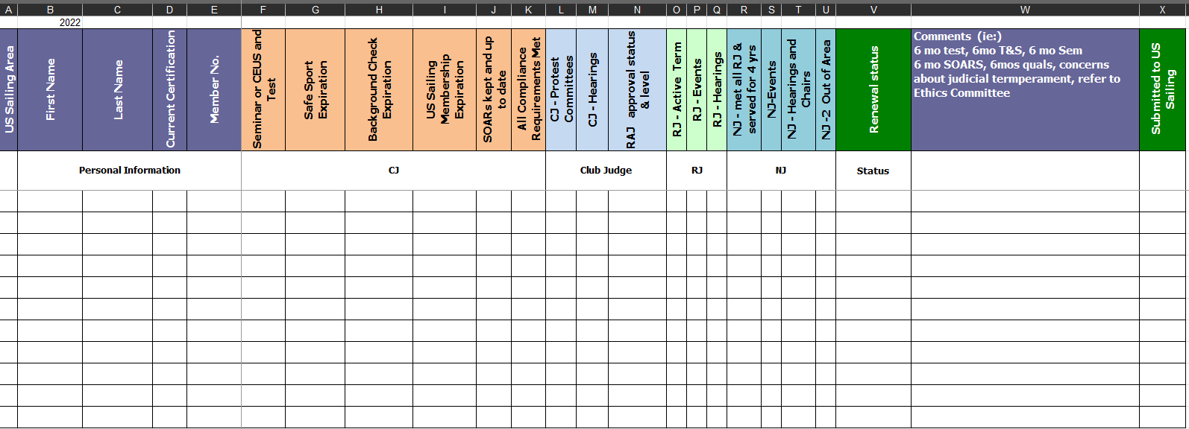

Complaints about Race Officials
If the RAJ receives a complaint about any race official’s performance or conduct, he or she should consult with the Chair of the JC and/or the RAD about how to proceed. Some complaints go on to the Race Administration Committee (RAC) through this link: Give Feedback on a Race Official - US Sailing

Attend US Sailing Judges Committee Meetings
Each RAJ is expected to attend bimonthly web conference meetings to discuss judge applications and other business of the JC. If the RAJ is unable to attend a meeting, he or she should ask another committee member to present Judge Candidates from his or her area.

RAJs are encouraged to attend the yearly in-person JC meetings when held.

RAJs are encouraged to attend in-person US Sailing meetings, such as the National Conference, Sailing Leadership Forum, National Sailing Programs Symposium and Regional Symposiums, whenever possible. These meetings offer opportunities for networking, development and leadership within the race officer corps. Continuing Education credit for participation in such meetings may be offered.

Prepare for JC Meetings
At least ten days before the scheduled meeting RAJs will receive application packages for all RJ and NJ candidates scheduled for consideration at the meeting from the JC Chair. These should be carefully reviewed before the meeting. If any information is missing, or if a question or problem arises with a candidate’s application, please contact the submitting RAJ or the JC Chair.

RAJs should be ready to present and recommend action by the JC on each candidate. Remember that a crucial component of the vetting process is that the candidate must be recommended with strong support by his or her RAJ.

Provide Leadership in Judging in the Area
Each RAJ should be a resource to the LSOs in their Area, answering any questions or referring people to others who can help, and resolving any judging issues that may arise.

- Help OAs and ROs find judges for their events
- Assist members to resolve problems with SOARS. The RAJ has administrative access to SOARS, and can edit event entry information that most members cannot. For more information, please see the SOARS documentation available at the bottom of the SOARS main Menu.

Occasionally members of the JC will send a request for regatta judges to the members of the JC. Forward these opportunities onto your Judge corps as appropriate for their certification level.

RAJs occasionally send out an email “Newsletter” to their Judges corps. We encourage the RAJ to copy all JC members so other RAJs can incorporate and reuse any good information into their own “newsletter”.

Judging Support for Area US Sailing Regattas
Each RAJ should offer any support requested by the judges responsible for both youth and adult US Sailing regattas or qualifiers conducted in their Area, and provide any appropriate requested liaison between those judges, the event Chair and the JC.

It is important to be aware of the certification requirements for race officers, umpires and judges for US Sailing championships and their area qualifiers. RAJs are sometimes called on to help find suitable judges. This information is found in Regulation 10.06 (Link to Regulation 10.06 can be found under 6. References at the end of this RAJ-GU).

SafeSport
RAJs help current JITs and certified judges and potential candidates understand the requirements for achieving and maintaining judge certification. A fairly new requirement of all certified officials is SafeSport Certification. Detailed information on SafeSport can be found at on the Web-site under Race Officials/Quick Links

Under federal law (Public Law 115-126), the Center for SafeSport has authority over all of the national governing bodies (NGBs) of Olympic and Paralympic sports in the United States to investigate and resolve claims of sexual misconduct or abuse. As the NGB for the sport of sailing, US Sailing is responsible for investigating reports of physical or emotional misconduct (including bullying, hazing or harassment), and for administering the SafeSport program and implementing disciplinary decisions issued by the Center for SafeSport. SafeSport training is mandated by the US Sailing Board of Directors for all certified race officials, coaches, instructors, instructor trainers and Safety at Sea moderators, as well as Directors, staff and members of the Olympic Sailing Committee. This list of “covered individuals” is subject to annual review. Periodic training is required.

Background Checks
US Sailing approved a policy to have all US Sailing officials have background checks. This policy was approved November 2019. Information on background checks is on the Web-site under Rules/Officiating Resources – SafeSport & Race Officials. It is found below the SafeSport information under the Background Checks for Race Officials.

Policy on Use of US Sailing Logo by Certified Officials
US Sailing Judges Flag: When a protest committee is on duty afloat or ashore and the chair is a Certified US Sailing Judge, members may display the US Sailing Judges flag.

Use of the US Sailing logo is encouraged on announcements and flyers for Judge Seminars. 7.02 of US Sailing Regulations says: Members of US Sailing are permitted and encouraged to utilize the logos, seals, name, banners, flags, or the burgee of US Sailing in a non-commercial manner to promote its visibility within the sport and to the general public, reinforce its purposes stated in the bylaws, and promote a positive, healthy image. Such use shall not imply any endorsement by US Sailing for the associated activity. In cases of improper use, such permission may be withdrawn by the Marketing Director.

Extensions to Recertify
When a certified judge is up for renewal but has not completed all tasks to recertify, they may be given a six-month grace period by the JC to complete any missing items for recertification. Issues may include, but are not limited to, SOARS is not current, a NJ has not completed required Out of Area events, Seminar or CEU hours are missing or the test has not been passed.

Often when they complete the missing items such as passing the test, the RAJ notifies the JC Chair, who then approves the recertification without further JC involvement.

Developing a Plan for Improvement
US Sailing in 2020 is developing this plan. When developed, the information will be submitted at: Race Official Plan of Improvement v2 (jotform.com)

Judge Emeritus
US Sailing has established a Judge Emeritus designation to recognize judges who have given many years of distinguished service to the sport and have demonstrated significant leadership in the judging community.

More information can be found in the US Sailing Judges Manual.

Sample Recommendation:

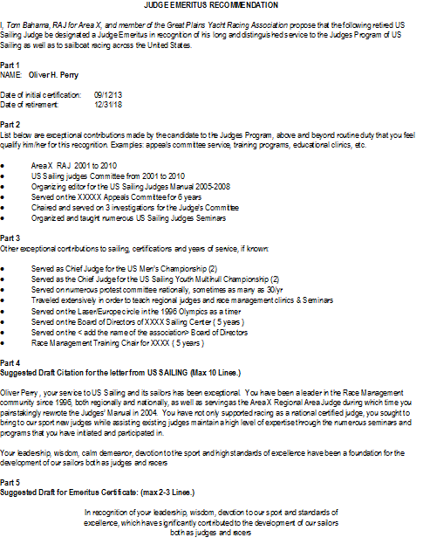

International Judge Appointment Requirements
US Sailing must nominate a Candidate for an initial appointment as a World Sailing International Judge with the United States as their MNA. After reviewing and voting, a recommendation by the Judges Committee is made to the RAC and then to the Board of Directors.

The Judges Committee may review candidates for re-appointment.

Process for Requesting Nomination as International Judge
The JC has an IJ Candidate Mentor as a resource to help a candidate successfully become an IJ. The Mentor is a JC member.

The Candidate shall file online an application with US Sailing applying to become a World Sailing International Judge. The application process through US Sailing is in addition to that which is required by World Sailing.

The candidate must request that each reference fill out an online reference form. US Sailing may contact the references named in the Application for Nomination for further discussions. While the references will be strongly encouraged to share their comments with the candidate directly, confidential references will be accepted if the reference so requests.

The applicant is responsible for following-up and ensuring US Sailing receives the completed reference forms.

Applications, including all required reference forms, will be reviewed by the JC in a closed session, which may be by teleconference.

The JC may seek independent confirmation of the candidate’s capabilities and experience by contacting other judges known to have worked with the candidate.

The JC will forward their recommendations to the RAC and the US Sailing Board of Directors for final approval.

Upon approval of the US Sailing Board of Directors, US Sailing will forward the application to World Sailing in accordance with the deadlines stated in the World Sailing Regulations

JC Timeline for IJ Application Processing/Review
The RAJ of an IJ candidate plays an important role in reviewing and presenting the candidate’s application to the JC. Below is the timeline and target times for the US Sailing process, starting at 10 weeks before the August Board of Directors meeting.

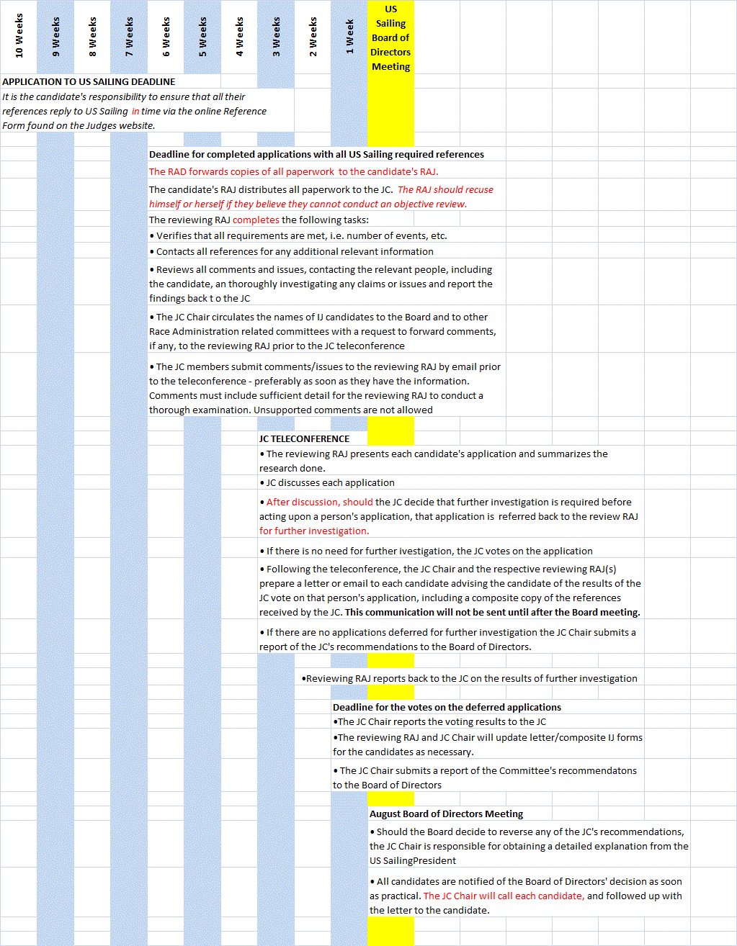

Confidentiality Principles for IJ Application Process
The applications and references will be confidential within the JC. All discussion of the candidates/applications by any JC member with the candidate or references is confidential. Only the reviewing RAJ or the JC chair should discuss the application with the candidate. With regard to issues raised during the JC review process, the source of the comments will be kept confidential if the source so requests. The substance of the issue will be shared with the candidate if found to be valid. References will be encouraged but not required to share their comments with the candidate directly.

Process for IJ Recertification
IJ’s reapplying for World Sailing Certification do so directly with World Sailing. World Sailing informs US Sailing of the names of the candidates who have applied for renewal.

The JC makes comments, if deemed appropriate, to the Board of Directors. The Board of Directors may direct that those comments be forwarded to World Sailing.

Judges Committee

Purpose
The Judges Committee develops, supports, trains, and certifies judges within the jurisdiction of US Sailing.

To provide this support, the Committee:

- Maintains the training and testing programs for certification and education of judges;
- Investigates complaints against judges;
- Supports and advises on the roles and conduct of judges for events nationally and at US Sailing events;
- Reviews the applications from US Sailing judges who seek certification as a World Sailing certified judge and provides recommendations to the Board of Directors regarding their nomination.

Functions and Activities
The Judges Committee shall:

- Maintain and document the criteria for certification as US Sailing Judge at any level;
- Oversee the development of new judges;
- Process initial applications and certified judge renewals, and approve qualified candidates for certification;
- Through JETTS, develop and maintain training and testing programs for certification and education of judges.
- Investigate complaints against judges;
- Assist other committees and organizations within US Sailing in obtaining qualified judges for events;
- Provide support for and advice on the roles and conduct of judges at US Sailing events;
- Maintain and document the criteria for obtaining a nomination from US Sailing for certification for all levels of certification;
- Evaluate applications of World Sailing International judges and make recommendations to the Board concerning the nomination of these applicants to World Sailing;
- Document the roles and responsibilities of Regional Administrative Judges;
- Maintain and update documents to support judges in the US. This includes, but is not limited to, the US Sailing Judges Manual, RAJ Guide and various Guidelines.
- Perform other duties related to the Judges Committee’s purpose as directed by the President and the Board of US Sailing.

Composition
The Judges Committee shall consist of voting and non-voting members. The Judges Committee voting members shall consist of a Chair, a Vice Chair (if appointed), eleven (11) RAJs that represent each of the US Sailing Areas, a Marketing and Communications Lead, the Chair of the Umpires Committee (ex-officio), and the Chair of JETTS. A Secretary shall be appointed as a non-voting member and the Chairs of any subcommittees, if not included above, shall also be included as non-voting members.

Judges Committee Leadership

Judges Committee Chair

Appointment
The Chair shall be appointed by the US Sailing President in accordance with US Sailing Regulation 6.01 and may not serve more than four (4) consecutive terms unless the Board of Directors of US Sailing approves an exemption.

Term of Office
The Chair of the Judges Committee shall serve a one (1) year term beginning and ending at the close of the AGM.

Duties
Chair JC web conference meetings, which generally occur bi-monthly. Chair the Annual JC Meeting. Review the applications for Regional and National Judge Certifications to be considered at the next JC meeting. Solicit items to be discussed at meetings from members of the JC. Generate the agenda for JC meetings. Select a secretary as required. Respond to questions from members about certification as needed. Consult with the Race Administration Director (RAD) on these and any other matters that concern the JC. Consult with the RAD and Chairs of Race Officers and Umpires Committees on matter of concern to all three committees. Serve as a member of the Race Administration Committee and ex-officio member of the Umpires Committee.

Judges Committee Vice-Chair

Appointment
Appointed at the discretion of the Chair of the Judges Committee.

Term of Office
The Vice Chair of the Judges Committee shall serve a one (1) year term beginning and ending at the close of the AGM.

Duties
The Vice Chair will serve at the bequest of the JC Chair and shall perform the duties requested by the JC Chair.

Judges Committee Secretary

Appointment
Appointed at the discretion of the Chair of the Judges Committee and in accordance with US Sailing Regulation 6.03.

Term of Office
The Secretary shall be appointed for a term of three (3) years, beginning and ending on December 31st, of their final term, and may not serve more than two (2) consecutive terms, unless the Judges Committee approves an exception.

Duties
Take notes at the JC meetings and distribute minutes as requested by the Chair.

Judges Committee Working Parties & Subcommittees
The JC may form, as necessary, Working Parties (WP) or Subcommittees to assist in performing the duties of the Judges Committee. Members of these WPs or Subcommittees are appointed by the JC Chair.

The Chair of a Working Party or Subcommittee shall become a member of the Judges Committee, increasing the size of the Judges Committee, if the Chair is not already a member of the JC.

Appointment
The Chair shall be appointed in accordance with US Sailing Regulation 6.03. The Chair of the JC will appoint the Chair of any JC Working Party or Subcommittee as needed.

Term of Office
The Chairs of Working Parties or Subcommittees shall be appointed for a term of three (3) years, beginning and ending on December 31st, of their final term and may not serve more than two (2) consecutive terms, unless the Judges Committee approves an exception.

Duties
All Working Parties or Subcommittees shall have terms of Reference that shall be approved by the Judges Committee and the US Sailing Board of Directors.

Standing Subcommittees

Judges Education Training and Testing Subcommittee (JETTS)

JETTS creates and maintains the materials that support the Judges Committee's training and testing programs for all certification levels of US Sailing Judges.

International Judge Mentoring Subcommittee
The IJ Candidate Mentor is a resource to help candidates successfully navigate the IJ certification process. The IJ Candidate Mentor is a JC member.

Web Liaison Subcommittee
The Judges Committee may appoint a Web Liaison who will maintain the Judges’ Website. A web liaison will not be a voting member of the Judges Committee unless otherwise a member of the Judges Committee.

References

Links
Not all links in the guide are shown here. The following resources are available on the Judges page of the US Sailing website unless another location is given.

Main Contact at US Sailing
Race Administration Director is listed last on the Judges Committee contact list as Staff Liaison. RAD contact information is also on the bottom of the Judges page.

These items are found on the Judges page under Resources

US Sailing Judges Manual

US Sailing Judge Certification Requirements

Judge Continuing Education Guidelines and Events
Continuing Education Guidelines.
Continuing Education Events and CEUs Table is a table defining the continuing education values for educational events.

SOARS
SOARS

World Sailing International Judge Application Requirements
2023 Version: International Race Officers – World Sailing

SafeSport and Background Checks
Link

US Sailing Regulations
The sections of the latest US Sailing Regulations that are referenced in this RAJ-GU can be found under Resources on the Bylaws and Regulations page.

Web Conferences – Hosting your own
The JC uses Zoom for Web calls. Anyone can sign up with Zoom for free and hold a web conference call. The free version has 40 minute time limit with up to 100 people, but is fine for test debriefs and may be long enough for PC Hearings if needed. To host longer conferences, one person needs the paid version. It is $15 a month. www.zoom.com.

