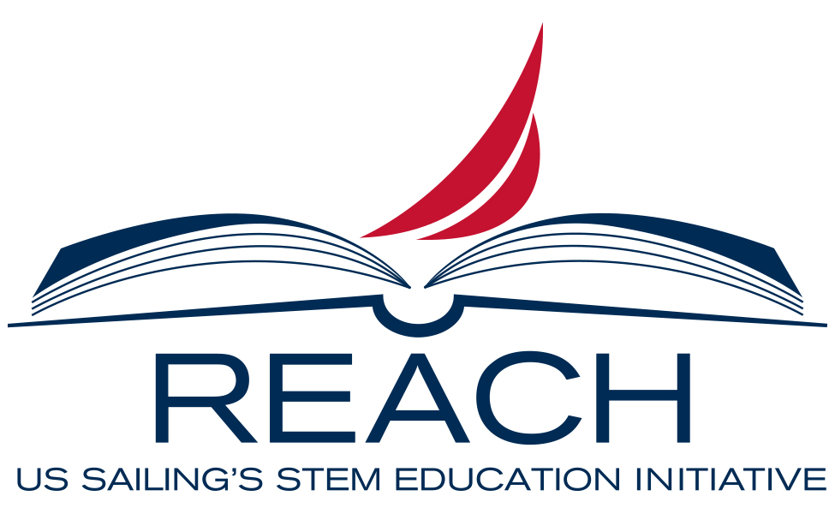
2021 Reach Initiative
Growing Capacity: Systemic Incorporation of STEM & Environmental Education through Sailing
Request for Proposals – Youth Engagement

Purpose
Reach Youth Engagement grants have been made available to provide financial support for materials, transportation costs, and offsetting staff costs when implementing the Reach Initiative. This area of need was identified through the Reach mentoring sessions and educator surveys. Support from Rolex and US Sailing donors has made these grants possible.

Criteria for Applicants
- Utilize US Sailing Small Boat Level 1 or Basic Keelboat certified instructors for all on-water activities.
- Current US Sailing Organizational Member.
- Must be a 501(c) 3 non-profit organization.
- Must attend one virtual mentor session.

Timeline
- Proposals due: June 1, 2021.
- Notification of award: June 9, 2021.
- Signed contract due: June 14, 2021.

Award/Grant -
- $3,500 grant to use on program materials, transportation costs, and offset costs when implementing the Reach Initiative. At least one staff or volunteer is highly encouraged to register for a Reach Educator Course.

Reporting
Submission of a one-page final report is due by Friday, October 31st, 2021.

Report Criteria:
- Pictures and Testimonials (quotes)
- Data on student attendance, type of program and number of modules completed.
- Expected student retention.
- Partnerships and STEM events (if applicable).
- Staff or volunteers who attend a Reach Educator Course.
- Complete budget table.

Application Process
Please submit the application and a copy of your W-9 by email to Jen Guimaraes: jenguimaraes@ussailing.org.

Organizational Information
Name of Organization (as stated on IRS 501(c)(3) letter):
Name of Organization (if different from above):
IRS Tax ID Number:
Street Address: City: State: Zip Code:
Mailing Address (if different): City: State: Zip Code:
Website:
Mission:

Contact Information
Contact Name: Title:
Email Address: Phone Number:

Please briefly answer the following:
- Approximately how many students will participate in Reach modules at your organization this year?

- Briefly describe your Reach programming history and number of youth impacted:

- List and briefly describe your youth and community partnerships in relation to Reach:

- Describe how this grant will help you engage more youth in STEM, sailing, and stewardship:

Budget for use of $3,500 that pertains to this grant (adjust descriptions as needed):
Description | Amount
Materials
Student Scholarships
Events
Travel
Other:
Total | $3,500.00

List the name(s) and member number(s) of US Sailing Small Boat Level 1 and/or Basic Keelboat and Reach Educator Course certified Instructors used in your program for on-the-water activities (add more lines as needed):
Name | US Sailing Certification & #

Please include the following:
- Digital copy of organizational logo in .jpg or .gif format.
- Copy of your Organization’s IRS Form W-9

