Adapting to Sailing and Thriving
By Jay Baum
Quemuel Arroyo grew up on an island
, but when that island is Manhattan, the nearest yacht club might not be the sort of place you can just wander into.
“I grew up in Hamilton Heights, Manhattan, and though I lived next to the Hudson River, my family, and the rest of my Black and Latino community had no access to experience the water,” explained Arroyo, who goes by “Q.”
However, he did sail on Long Island Sound as a high school freshman through NYC Outward Bound Schools, and he continued to sail occasionally with friends who had connections to boats. While on that first Outward Bound trip he met Robert Burke, who would later become the Executive Director of Hudson River Community Sailing (HRCS), and they stayed in touch.
Following a spinal cord injury, Q was invited to join HRCS, and sailing became a collaborative effort. While HRCS runs an annual event called Heroes on the Hudson for disabled veterans, the organization didn’t have a lot of experience with sailors in wheelchairs. Q, already an advocate for people with disabilities through his work with the NYC Department of Transportation, and later at the micromobility firm Charge, added his valuable viewpoints to the club, while developing his sailing skills as a member. In 2018 he joined the HRCS Board of Directors.
“Sailing with my disability is a world of a difference from how I remember it.”

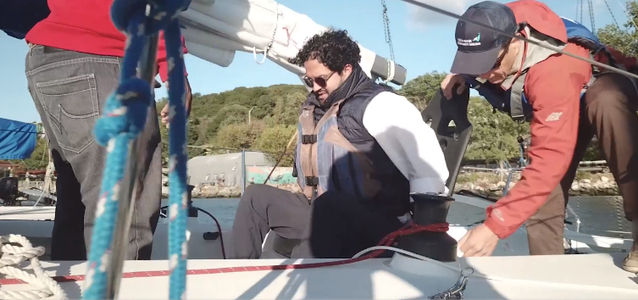
In 2019, HRCS began prototyping a chair and adapting a J/80 for him to test. This gave him better control for helming the boat which allowed Q and his team to compete in the J/80 class at the 2019 Sailing for Scholars Regatta.
(more about HRCS and the 2019 regatta at https://vimeo.com/367052785)

Q and Hudson River Community Sailing are a good fit for each other. As a community sailing center with a goal of “providing sailing education within a supportive, diverse community,” expanding its adaptive program has been a high priority. As Q explains, “I'm back to sailing because the staff at HRCS has embraced the challenge of getting a paraplegic at the helm of a boat.”
“The sailing community has welcomed me fully; all I am and all I bring is celebrated amongst my sailing family.”

