Debora Abrams-Wright is Leading Comrades-in-Arms and More
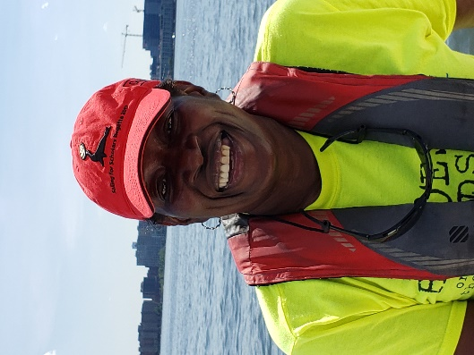
As the Chairman of the US Sailing Diversity, Equity and Inclusion Committee and as a recent addition to the Board of Directors at Hudson River Community Sailing (HRCS), Sergeant Debora Abrams-Wright has come a long way in a relatively short time.
Abrams-Wright first set sailing from Long Island as an adult in the early 1990’s, “but it was short lived and I didn't learn much,” she admits. A lifelong learner, she picked up sailing again some 20 years later, long after leaving active service, while working at the Veterans Administration as an Employment Specialist assisting veterans like herself. She had also started an organization, Veterans Adaptive Sports NYC, to help vets take advantage of the many free sports programs that were available around New York City (all of which she has participated in). Debora first organized Veterans On Guard, a fencing program, and soon she was honing her fencing skills while competing in local tournaments!
The second program she helped veterans join was sailing with Hudson River Community Sailing’s Soldiers Under Sail, which has given veterans lessons and club memberships since 2014.
“There is a reluctance for many people to approach a sailing club because it seems unattainable. I think that clubs need to make more of an effort to invite untapped communities to join. It requires education on both sides.”
“I was one of the only female vets to join the program and only a few of us were persons of color,” she said. “There weren't many vets at the start of the program. I was also in my mid-fifties at the time, but I was hooked. Program Coordinator Don Rotzien made all of us feel very comfortable and welcome as we began this journey.”
The program is structured so that vets can go out as a group twice a week on scheduled sails with staff, sail as often as they want as crew on open club boats, take the US Sailing Basic Keelboat course, and even certify as a club skipper so that they can lead their own crew.
Many of the veterans find comfort sailing with their comrades-in-arms and may not care to expand beyond the close-knit group, but Abrams-Wright consistently encourages the vets to become active in the club community and to integrate themselves into the mainstream of the club.
“I’m the type to engage in any situation, but not everyone is like that. I want them to feel comfortable stepping into this unknown. I want them to thrive and not be afraid of what is to come,” she said.
Her role also serves to bring these vets out of their comfort zone and to help them acclimate to the club community, which she’s been successful in doing.
“I feel that it’s the same with those who don’t feel comfortable engaging in something new and different. It takes some coaxing for them to understand that they can be out here doing this just like anyone else - just like me. It also requires them seeing people who look like them and who are like them.”
Abrams-Wright took advantage of all these opportunities and more, and in just a few years she has become a presence on the regional sailing scene. She has worked with SailAhead, a veteran sailing organization based on Long Island (NY); competed in offshore distance races and local races; sailed with disabled veterans in HRCS’s Heroes on the Hudson events; and joined the board of the Clagett Memorial Regatta Foundation.
“This journey has taken me to Newport, R.I. where I have participated as a member trying to engage not only veterans, but the underserved community as well. I had the opportunity to participate in the Clagett – Oakcliff Regatta two years in a row as crew for a disabled sailor, doing match racing. I was able to race against blind sailors, amputees, and wheelchair-bound sailors. The disabled sailor must be the one on the tiller. During my 2nd regatta I was asked to crew for a blind sailor, she said.”
Learning what information the helmsman needed, and not overreacting by reaching for the tiller herself was difficult at first. “It is without a doubt the most challenging thing I’ve ever done in sailing, and match racing made it that much more complicated. I was solely responsible for relaying directions while he was on the tiller, she added.”
Now, as her home club ramps up its adaptive sailing program, she plans to certify as a Basic Keelboat Instructor and add the Adaptive Sailing endorsement, eventually getting her Coast Guard 6-pack credential.
Abrams-Wright continues to lead her colleagues, now working with an even broader team of sailors. “My goal extends beyond just veterans. There are so many people out there that wish they could do this, or would gladly want to be exposed to this, but we have to make this possible by extending a hand that lets them know that they are welcome. We need to bridge the gap - and it is a large one. I hope to make a difference in the current climate of sailing where ALL are welcome and encouraged to participate in this sport.”
“Our mission as a DE&I committee is to help connect sailing clubs with all of the underserved groups out there who have yet to see themselves as a part of this.”
Debora Abrams-Wright can be reached at dawright1@gmail.com, and through Veterans Adaptive Sports NYC, vetsadaptivesportsnyc@gmail.com, 917-893-2363

