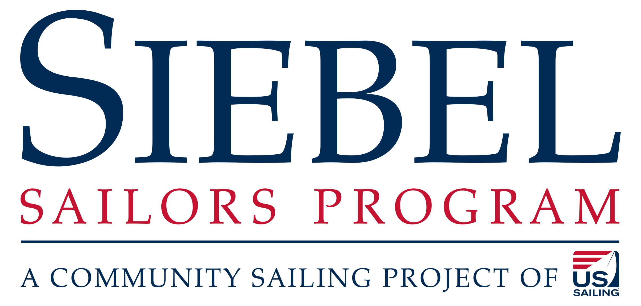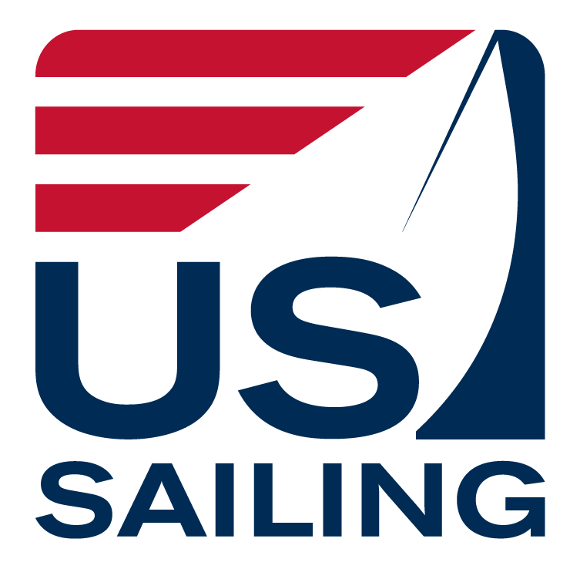

Siebel Program Coach - Job Description

Position Summary

The Siebel Sailors Program seeks to increase opportunity and diversity in the sport of sailing. By providing resources and support to youth sailors from all backgrounds we will develop skilled and life-long sailors who can participate in all aspects of the sport by creating access to equipment, athlete development resources, and expert coaching for underserved populations.
The right candidate for this position will be a catalyst for change that promotes ideals such as skill development for all sailors, professional growth for coaches and a greater understanding of the sport for parents. Based out of a Siebel Center, this individual will utilize US Sailing’s Sailor Skill System and Skill Up App, to help “connect the dots” to higher levels of sailing. They will facilitate training sessions and clinics for youth and serve as a resource for other area coaches.

Essential Duties and Responsibilities
- Develop, and manage, a multi-site practice schedule utilizing the Siebel Network Programs. Coordinate the planning and execution of events such as practices, training camps, clinics, and other competitive development events. This includes running several youth racing clinics annually.
- Oversee the logistical management of four separate fleets of sailboats. Bringing the fleets together, when needed, for larger events.
- Identify ways to assist programs in increasing diversity (gender, racial and socioeconomic) and increase retention.
- Assist Network Programs in aligning their existing curriculum to the US Sailing’s Sailor Skill System.
- Train Program staff and sailors to utilize the Skill Up App and track sailors progress.
- Assist the Program Manager with implementing a Performance Quality Assessment (PQA) program. This includes pre and post testing for students. Present outcomes at the annual National Coaching Symposium.
- Participate in continuing education programming provided by, or through, US Sailing. This includes participating in US Sailing Select Camp and the USOC National Teach Coach Leadership Education program (if accepted via application).
- Build, facilitate and maintain relationships with Local Sailing Organizations (LSOs). Primary focus will be on the sailors directly involved with the Siebel Program with a secondary focus being to support the general needs of Siebel Network Programs, specifically the one that you will be based from.
- Serve as a communications conduit between US Sailing and regional sailing community. Direct news and content from region to US Sailing’s Communications Manager and news from US Sailing to region.
- Provide excellent customer service skills, written and verbal communication skills and strong organizational skills with precise attention to detail are required.
- Communicate to stakeholders about US Sailing’s products, services and operations. Promote US Sailing to LSOs, building a national presence and market for US Sailing.
- Become the "Go-To Person" for all things Youth-related in your area.
- Provide training to other coaches, and work with program managers to ensure alignment with US Sailing’s curriculum. Assist with continuing education opportunities for other coaches. This includes, but is not limited to, sharing resources, direct mentorship, observation and recommendations to US Sailing about appointments for formalized continuing education opportunities for other coaches.
- Provide clear, timely, and comprehensive communication with participants and supporters.

Minimum Qualifications (Knowledge, Skills, and Abilities)
- National coaching experience with firm understanding of skill development at all levels.
- Experience working in both Community Sailing programs and Yacht Clubs is a plus.
- Bachelor’s Degree in a relevant field.
- Must be self-motivated and detail oriented.
- Possess a commitment to and experience in providing first-class customer service.
- Possess strong written and oral communications skills, specifically writing letters/emails, public speaking, and comfortable speaking on the telephone.
- Possess strong problem-solving skills and follow through on projects and tasks.
- Strong track record of management experience
- Proficient in Microsoft Office (Excel, Work PowerPoint), standard web content management systems and database applications.
- Minimum of US Sailing Level 3 Instructor Certification (or willingness to become certified).
- Must have a clean driving record

Physical Demands and Work Environment
The physical demands described here are representative of those that must be met by an employee to successfully perform the essential functions of this position. Reasonable accommodations may be made to enable individuals with disabilities to perform the functions.

While performing the duties of this position, the employee is regularly required to talk or hear. The employee frequently is required to use hands or fingers, handle or feel objects, tools, or controls. The employee is occasionally required to stand; walk; sit; and reach with hands and arms. The employee must occasionally lift and/or move up to 25 pounds. Specific vision abilities required by this position include close vision, distance vision, and the ability to adjust focus. The noise level in the work environment is usually low to moderate.

Other
- Employee will be provided with a mobile phone and laptop.
- Must possess the highest integrity and values consistent with those of US Sailing.
- Frequent overtime and travel, including weekends and over the summer months, due to demands of position and schedule of events.
- Importance of being a team player: All US Sailing employees are expected to be exceptional team players.
- Requires confidence, job knowledge and ability to utilize available resources to provide excellent service for organizations.
- A passion for helping people.
- Must possess excellent organizational and prioritization skills along with the ability to multi-task and problem solve.
- Growing Membership: Each employee is expected to work together to assist in growing US Sailing membership.
- Position requires occasionally representing US Sailing at events throughout the year, and public speaking at several events including US Sailing Meetings.

Note
This job description in no way states or implies that these are the only duties to be performed by the employee(s) incumbent in this position. Employees will be required to follow any other job-related instructions and to perform any other job-related duties requested by any person authorized to give instructions or assignments. All duties and responsibilities are essential functions and requirements and are subject to possible modification to reasonably accommodate individuals with disabilities. To perform this job successfully, the incumbents will possess the skills, aptitudes, and abilities to perform each duty proficiently. Some requirements may exclude individuals who pose a direct threat or significant risk to the health or safety of themselves or others. The requirements listed in this document are the minimum levels of knowledge, skills, or abilities. This document does not create an employment contract, implied or otherwise, other than an “at will” relationship.

Application Process
To apply for this position, please visit https://www.ussailing.org/about/our-people/careers/

