2019 Reach Initiative
Growing Capacity: Systemic Incorporation of STEM & Environmental Education through Sailing
Request for Proposals - Center of Excellence (Mid-West and Southern California)

Purpose
To strategically expand the national network of regional Reach “Hubs” led by “Centers of Excellence” that serve as models of best practices and share learning resources with surrounding “Reach Centers” and “Reach Programs”.

A Reach Center of Excellence (year 2 and beyond) – will act as an experienced anchor program to offer an immediate channel to increase participation and offer a sustainable, long-term model that can be replicated in other cities. Focusing on strategic partner-building and mentoring, the Center of Excellence will connect with university partners, schools, and STEM companies to create a strong STEM foundation and pathway to STEM careers for Reach participants. The organization will remain a US Sailing Reach Center of Excellence as long as they are meeting “Center of Excellence” Criteria.

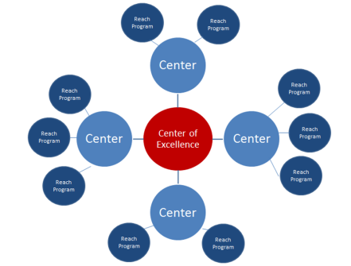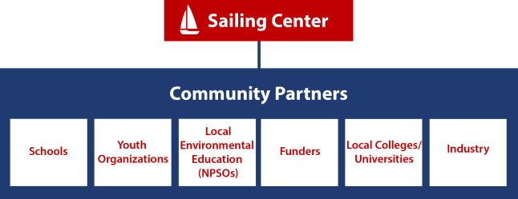

Criteria for Applicants
- Currently implementing at least 5-7 Reach modules or more to 100+ youth annually for at least one year.
- Previous identification as an “Emerging Hub.” All criteria in previous year was met and center is in good standing.
- Located in a major US city
- Utilize US Sailing Association Level 1 or Basic Keelboat certified instructors for all on-water activities
- Must be a 501(c)3 non-profit organization
- Agree to secure a 25% match grant match ($2,500) and show proof of funds by the end of the grant. (new individual donations, sponsorship, or grants are applicable)
- The organization must be committed to sharing best practices in STEM, sailing, and environmental education through US Sailing’s Reach Initiative with surrounding programs.
-2018 Reach student pre test Modules 1-6: https://www.surveymonkey.com/r/2018Reach_Pretest
-2018 Reach student post test Modules 1-6: https://www.surveymonkey.com/r/2018Reach_Posttest

Timeline
- Proposals Due: March 1st, 2019
- Notification of Award: March 22nd, 2019

Award/Grant
Center of Excellence – up to $10,000

Grant Activities
The “Center of Excellence” will engage in the following activities, increasing the quality of STEM and environmental programming in their own organizations as well as provide resources for initial programs.

- Mentoring: 2 representatives from your organization must host, schedule speakers, and participate in two mentoring sessions (Spring/ Fall).
- Assessment:
  - STEM PQA – Participate in a funded one-hour quality assessment observation with a ½ hour debrief. Organizational data will contribute to overall Reach Initiative data. ($1,000 value)
  - Student Pre/Post – Select a group of 18-30 students participating in 3-5 Reach Modules that will complete pre and post tests. Administer pre/post tests and mail to US Sailing with a report sheet.
    - Student pre test Modules 1-6: https://www.surveymonkey.com/r/2019ReachPre
    - Student post test Modules 1-6: https://www.surveymonkey.com/r/2019ReachPost

- Professional Learning: New Reach instructors or volunteers will attend a Reach Educator Course
- Reach Resources: Share a Reach resource that other sailing centers implementing Reach can use as a resource. Examples: Instructor Cards, Reach Program Budget, Reach Pathway for students, or Sustainability Plan. Format: (1-page pdf, doc, including your logo)
- Event: Host or participate in a STEM based event that incorporates a portion of the Reach curriculum.
- Partnerships: Establish one new strategic partnership that will increase student participating in STEM, sailing, and sustainability.
- Marketing: Submit 3-5 photos of Reach in action at your Center. Additional photos welcome but not required.

Reporting
Submission of a one-page final report is due by Friday, October 18th, 2019.

Application Process
Please complete the attached application and a copy of your W-9 by email to Reach@ussailing.org

Organizational Information
Name of organization (as stated on IRS 501(c)(3) letter):

Name of organization (if different from above):

IRS Tax ID Number:

Street Address: City: State: Zip Code:

Mailing Address (if different): City: State: Zip Code:

Website:

Mission:

Contact Information
Contact Name: Title:

Email Address: Phone Number:

Please briefly answer the following:
- Approximately how many students will participate in 5-7 Reach modules at your organization this year?

- Briefly describe your Reach programming history and number of youth impacted:

- List and briefly describe your youth and community partnerships in relation to Reach:

- How will your organization continue as a “Center of Excellence in future years beyond support from US Sailing?

- Please explain why your organization should be selected as the 2019 Reach Center of Excellence and why your community is in need:

Budget for use of up to $10,000 that pertains to this grant:
Description | Amount
Reach Educator Courses
Student Scholarships
Events
Travel to Mentoring Sessions
Other:
Total

List the name(s) and member number(s) of US Sailing Small Boat Level 1 and/or Basic Keelboat and Reach Educator Course Certified Instructors used in your program for on-the-water activities:
Name | US Sailing Certification & #

Please include the following:
- Digital copy of organizational logo in .jpg or .gif format.
- Copy of your Organization’s IRS Form W-9
- A letter of support from a local community leader or partner.

