2018 Reach Initiative
Growing Capacity: Systemic Incorporation of STEM & Environmental Education through Sailing
Request for Proposals - Emerging Reach Center of Excellence

Purpose
To strategically expand the national network of regional Reach “Hubs” led by “Centers of Excellence” that serve as models of best practices and share learning resources with surrounding “Reach Centers” and “Reach Programs”. In 2018, one “Emerging Center of Excellence” will be selected to help lead and mentor regional programs, grow their own strategic partners, and in turn increase the number of youth impacted through the Reach Initiative. The Emerging Center of Excellence will be mentored by the current Reach Centers of Excellence: Community Boating Center in the Northeast and the Downtown Sailing Center in the Mid-Atlantic. Support from 11th Hour Racing, Rolex and US Sailing donors has made these grants possible.

A Reach “Emerging (year 1) Center of Excellence (year 2 and beyond)” – will act as an experienced anchor program to offer an immediate channel to increase participation and offer a sustainable, long-term model that can be replicated in other cities. Focusing on strategic partner-building and mentoring, the Center of Excellence will connect with university partners, schools, and STEM companies to create a strong STEM foundation and pathway to STEM careers for Reach participants. The organization will remain a US Sailing Reach Center of Excellence as long as they are meeting “Center of Excellence” Criteria.

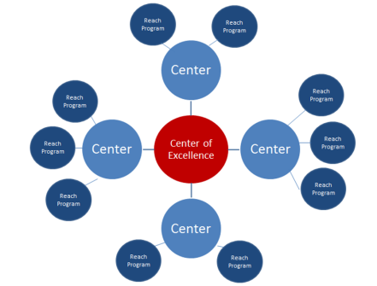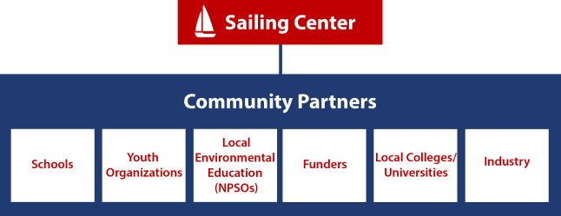

Criteria for Applicants
- Currently implementing at least 5-7 Reach modules or more to 100+ youth annually for at least one year.
- Located in a major US city in the Northwest, Midwest, or Southeast
- Utilize US Sailing Association Level 1 or Basic Keelboat certified instructors for all on-water activities
- Must be a 501(c)3 non-profit organization
- Agree to secure a 50% match grant match ($5,000) and show proof of funds by the end of the grant. (new individual donations, sponsorship, or grants are applicable)
- US Sailing Accredited Community Sailing Centers will receive priority.
- The organization must be committed to sharing best practices in STEM, sailing, and environmental education through US Sailing’s Reach Initiative with surrounding programs.

Timeline
- Proposals Due: March 2nd, 2018
- Notification of Award: March 13th, 2018
- Materials Shipped upon receipt of signed contract: March 20th, 2018

Award/Grant
Emerging Center of Excellence – up to$10,000

Grant Activities
The “Emerging Reach Center of Excellence” will engage in the following activities, increasing the quality of STEM and environmental programming in their own organizations as well as provide resources for initial programs.

- Mentoring: 2 representatives from your organization must travel to, attend, and participate in two mentoring sessions (Spring/ Fall) hosted by an existing Reach Regional Center of Excellence.
Mentoring Session #1: Mid-Atlantic (Baltimore, MD): Friday, April 20th 2018 8:30-4:30pm
Northeast (Providence, RI): Friday, May 4th, 2018 8:30-4:30 pm
Mentoring Session #2: September (TBD)
- Assessment:
  - STEM PQA – Participate in a funded one-hour quality assessment observation with a ½ hour debrief. Organizational data will contribute to overall Reach Initiative data. ($1,000 value)
  - Student Pre/Post – Select a group of 18-30 students participating in 3-5 Reach Modules that will complete pre and post tests. Administer pre/post tests and mail to US Sailing with a report sheet.
-2018 Reach student pre test Modules 1-6: https://www.surveymonkey.com/r/2018Reach_Pretest
-2018 Reach student post test Modules 1-6: https://www.surveymonkey.com/r/2018Reach_Posttest
- Professional Learning: New Reach instructors or volunteers will attend a Reach Educator Course
- Reach Resources: Share a Reach resource that other sailing centers implementing Reach can use as a resource. Examples: Instructor Cards, Reach Program Budget, Reach Pathway for students, or Sustainability Plan. Format: (1 page pdf, doc, including your logo)
- Event: Host or participate in a STEM based event that incorporates a portion of the Reach curriculum.
- Partnerships: Establish one new strategic partnership that will increase student participating in STEM, sailing, and sustainability.
- Marketing: Submit 3-5 photos of Reach in action at your Center. Additional photos welcome but not required.

Reporting
Submission of a one page final report is due by Friday, October 12th, 2018.

Application Process
Please complete the attached application and a copy of your W-9 by email to JessicaServis@ussailing.org

Organizational Information
Name of organization (as stated on IRS 501(c)(3) letter):

Name of organization (if different from above):

IRS Tax ID Number:

Street Address: City: State: Zip Code:

Mailing Address (if different): City: State: Zip Code:

Website:

Mission:

Contact Information
Contact Name: Title:

Email Address: Phone Number:

Please briefly answer the following:
- Approximately how many students will participate in 5-7 Reach modules at your organization this year?

- Briefly describe your Reach programming history and number of youth impacted:

- List and briefly describe your youth and community partnerships in relation to Reach:

- Please explain why your organization should be selected as the 2017 Reach Emerging Hub and why your community is in need:

Budget for use of up to $10,000 that pertains to this grant:
Description | Amount
Reach Educator Courses
Student Scholarships
Events
Travel to Mentoring Sessions
Other:
Total

List the name(s) and member number(s) of US Sailing Small Boat Level 1 and/or Basic Keelboat and Reach Educator Course certified Instructors used in your program for on-the-water activities:
Name | US Sailing Certification & #

Please include the following:
- Digital copy of organizational logo in .jpg or .gif format.
- Copy of your Organization’s IRS Form W-9
- A letter of support from a local community leader or partner.

