Station Attended | Station | STEM Trivia
 | 1 | How long does a plastic water bottle last for if it gets into the ocean?  Answer:
 | 2 | Do plastic water bottles sink or float?  Answer:
 | 3 | 1. What does PET stand for?  Answer:
 | 4 | What is the combustion engine replaced with in an electric car?  Answer:
 | 5 | Where is the official hottest place on earth?  Answer:
 | 6 | What does Archimedes' Principle tell us about the magnitude of the buoyant force applied by the water to a boat's hull?  Answer:
Station Attended | Station | STEM Trivia
 | 7 | Name and describe one International Maritime Communication Flag.  Answer:
 | 8 | List 2 results of Ocean Acidification.  Answer:
 | 9 | Name an instrument used to measure weather.  Answer:
 | 10 | How many panels are used to build an Opti?  Answer:
 | 11 | What effect does adding additional blocks/pulleys have on the amount of effort needed to trim your main?  Answer:
 | 12 | What doe ROV stand for?  Answer:

Social Media:
Tag @USSailing or Hashtag #USSailing #STEM

Note: Once you have completed all stations please bring your completed quiz to the US Sailing’s Reach Program Station and fill out a raffle ticket to be eligible for prizes.

US Sailing would like to thank the following people and participating organizations:
- Jim and Nelly Kilroy
- Heal the Bay
- Santa Monica Pier Aquarium
- Algalita Marine Research Institute
- Santa Monica High School's Team Marine
- American Meteorological Society, LA Chapter
- Loyola Marymount University
- Life Sail US Sailing
- Center Long Beach
- Sea Grant
- North Sails
- USODA

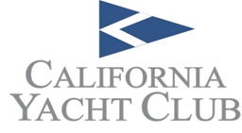
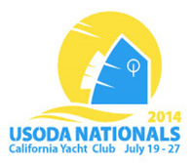

For more information visit reach.ussailing.org

Sailing through STEM Night
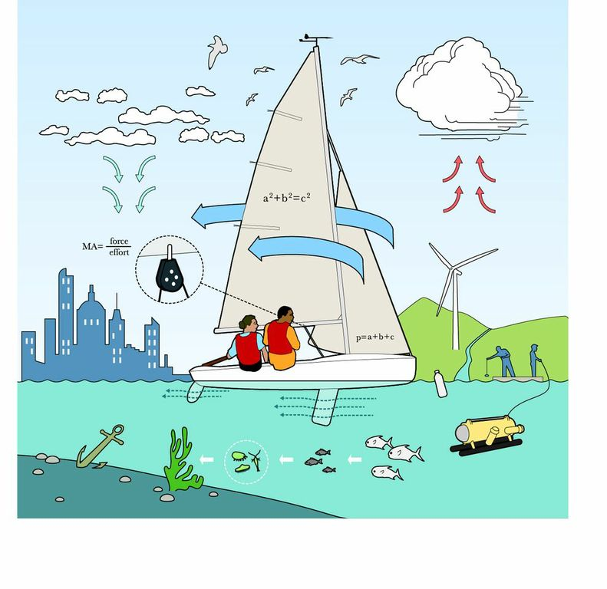

Timeline of Events
4-7 pm STEM Stations for Kids
7-7:30 pm Science and Technology of Opti Sails
By Mike Marshall, North Sails Designer
7-8pm Intro to Reach Cocktail Reception for Parents
