June 21, 2016

Mr. / Ms. <First name> <Last name>
Street Address or PO Box
City, State, Zip Code

Dear <Mr. / Ms. Last Name>,

The Judges Committee and US Sailing are very pleased to have the honor to bestow upon you the title of Judge Emeritus.

<First name>, your service to US Sailing and its sailors has been exceptional. You have been a leader in the Race Management community since 1996, both regionally and nationally, as well as serving as the Regional Area Judge during which time you painstakingly rewrote the Judges Manual. You have not only supported racing as a national certified judge, you sought to bring to our sport new judges while assisting existing judges maintain a high level of expertise through the numerous seminars and programs that you have initiated and participated in.

Your leadership, wisdom, calm demeanor, devotion to the sport and high standards of excellence have been a foundation for the development of our sailors both as judges and racers

Enclosed is a certificate indicative of our pride in your accomplishments and the appreciation of the tremendous support that you have given to the judging community. We would like to thank you for your dedication, time, skills and knowledge that you have given to the sport of sailing.

Good sailing!
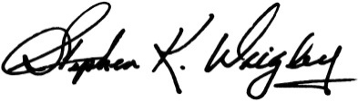

Stephen K. Wrigley
Chairman, Judges Committee, US Sailing

