P:\Art\Logos\training-eps-logos\certified_race_official.eps

*<insert name>*

has been designated as

*Judge Emeritus*

In recognition of your exemplary long and distinguished contribution as a leader, race official, and supporter of sailing and development of practices that typify the spirit of sailing, the US Sailing Board of Directors designates your Judge Emeritus.

In witness whereof, this certificate is issued the 28th day of March 2014.

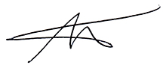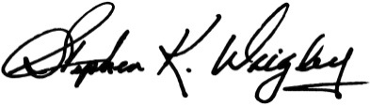

Stephen K. Wrigley Bruce J. Burton

Chair, Judges Committee President, US Sailing

*National Governing Body for the Sport of Sailing*