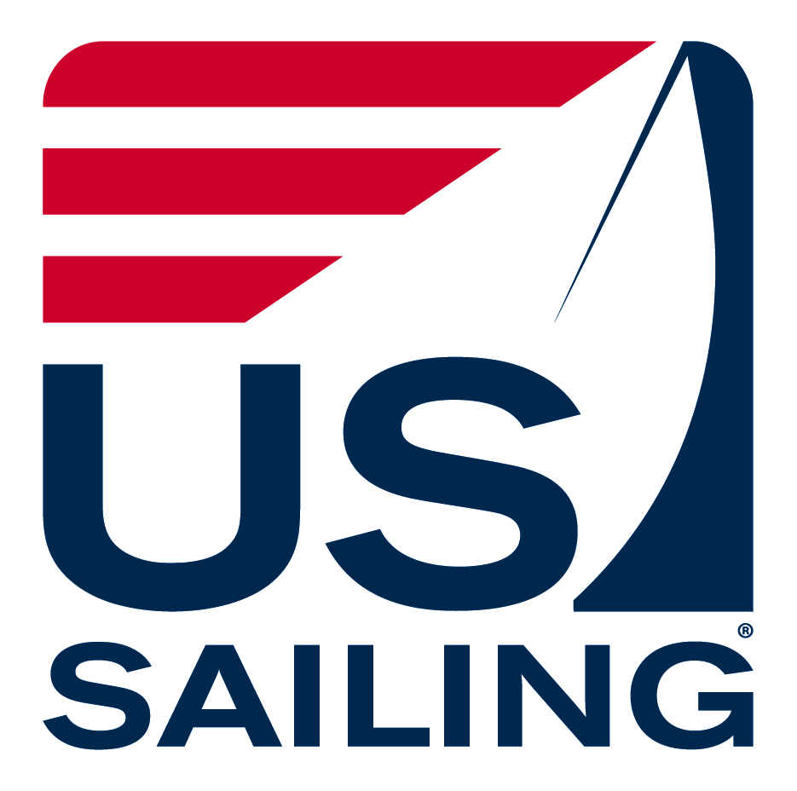
US SAILING TRAINING PROGRAM

LEVEL 2 COURSE RECORD FORM

TO BE COMPLETED BY INSTRUCTOR/COACH TRAINER (please print or type)

NAME SOC. SECURITY #
Last First M.I.
ADDRESS
No. Street City State Zip
PHONE (B) (R) _________________________ (F)

EMAIL______________________________________________________________________________________

COURSE INFORMATION

US Sailing Training Region Regional Training Coordinator

Course Location City __________________ ST ____________
Yacht Club/Sailing School/Camp

Date Course Began___________ Date ended______________

Course Contact ________________________________________Phone_________________________________

Email________________________________________________________________________________________

Address
No. Street City State Zip

Weather Conditions
Day 1 Day 2

Design of boats used: Sail ________________________ Power ________________________________
Condition of Equipment Supplied: Excellent Good Poor
Equipment Damaged: Yes No If Yes, explain:

Name of person mailing IC eval forms to Training Office___________________________________________

STUDENT INFORMATION
# of Instructor Candidates No. Passed Course No. Failed Course
Please provide names of students who have passed the classroom/water components of course: (list below)*
If there are additional students who pass the course, please attach an additional sheet with names of remaining ICs.

*NOTE: Students who have successfully passed the Level 2 course classroom/water components will be sent a link to complete the testing component of the Level 2 course online. In the case of a student taking a Level 2/3 course consecutively, students may complete the Level 3 classroom course prior to testing.

Instructor Trainer Signature Date _________________

